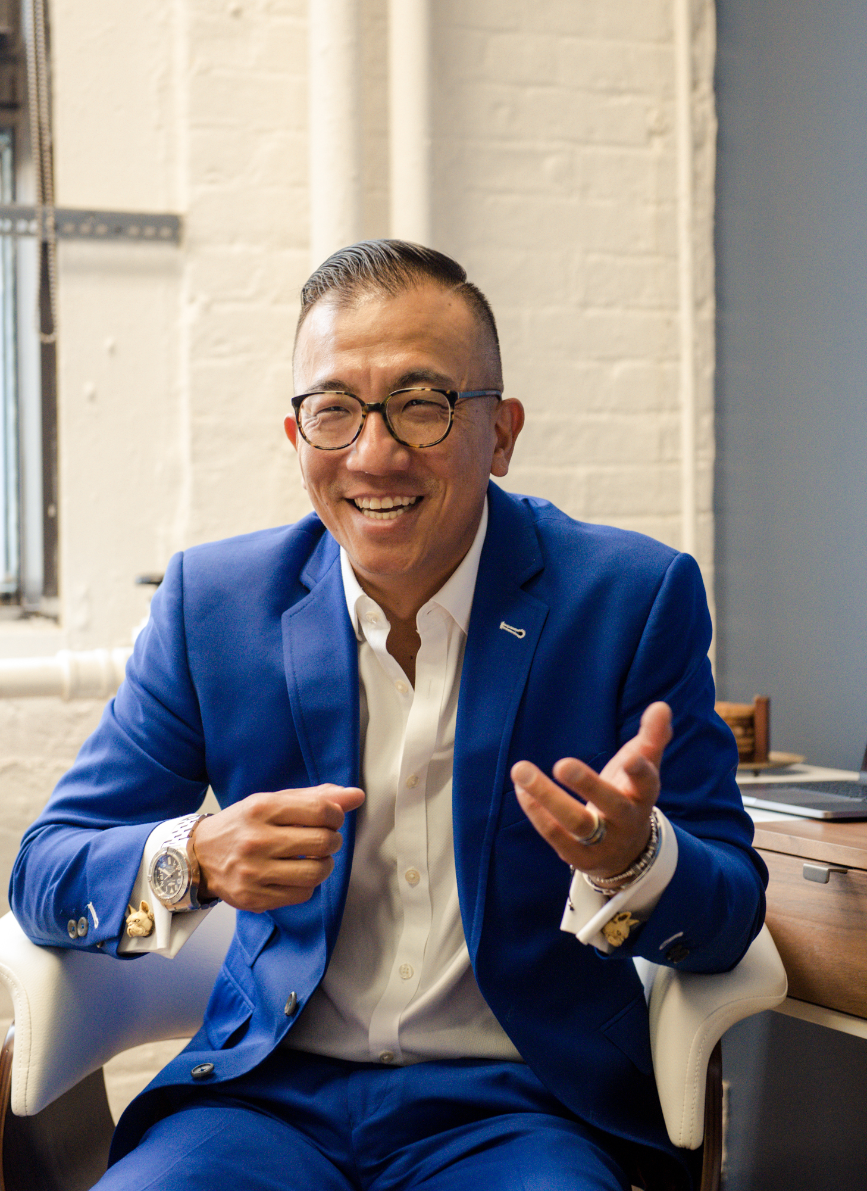

Benjamin Smithee
CEO
The Smithee Group
www.TheSmitheeGroup.com

Ben Smithee helps business leaders translate the future into a strategic roadmap they can start implementing today. He has been a featured speaker around the world across 6 continents and almost 30 countries. Ben has been a sought-after consultant for leading brands including McDonald’s, EA Games, Cox Automotive, Serena Williams, General Mills, ebay, Chase, Popeyes, Disney, Salesforce, and 100’s of startups and retailers.
Ben is the CEO of The Smithee Group (TSG), a Digital Growth Agency that offers a full suite of digital marketing and media solutions that leverages their extensive expertise in research, consumer insights, and data analytics.
He has founded 3 successful startups, and in addition to TSG he helps lead marketing for AltFund, an innovative Fund of Funds in the Crypto space.
Ben lives in Dallas, TX with his wife and daughter and when he is not in the business and non-profit worlds, you can find Ben on the track racing cars, on the mountain snowboarding, or on the links playing golf. His family attends Shoreline City church.

